**The Pursuit: Connect**

**Meeting Agenda**

**January 20, 2017**

* **New Member Welcome**
  + Tracey Spivey – Montgomery Coscia Greilich, LLP
  + Keith Pearson - Pearson Partners International
  + Melanie Ofenloch – Ofenloch Consulting
  + Burke Autrey – Fortium Partners
* **Upcoming Lunch Meetings 2016**
  + **Today’s Host:** Mark Girtz
  + 4/21/2017 – Andrew Marcus & TBD
  + 8/18/2017 – TBD
  + 10/20/2017 – TBD
* **Connecting Events**
  + Backroads (2/22/16)
* **Today’s Topic**:
  + Update on current Industry / Ideal Client

**Members:**

Janae Chamblee – First Business Resources 3 David Katzen – Katzen, Marshall & Associates 5

George Chamblee – First Business Resources 3 Michael Griffin – Transwestern 7

Mark Girtz - Munsch Hardt Kopf & Harr, PC 6 Andrew Marcus – Transwestern 7

Marti Cheatham – Bank of America 1 Melody Peevy – IMA Waldman Bros

Jenny Jeter – Merrill Lynch 2 Steve Waldman – IMA Waldman Bros

David Perez – Merrill Lynch 2 John Grimes – Duff and Phelps

Matt Groves -Montgomery Coscia Greilich, LLP 4 Jamie Katzen – Coats Rose

Tracey Spivey -Montgomery Coscia Greilich, LLP 4 Keith Pearson – Pearson Partners Internatioal

Linda Wilkins - Wilkins, Finston, Friedman Law Group Burke Autrey – Fortium Partners

Melanie Ofenloch – Ofenloch Consulting

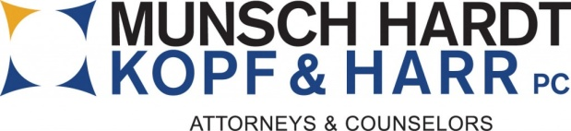

**Lunch Hosts:**

**Lunch Sponsors:**

Bank of America - 10/23/2015

Merrill Lynch - 1/29/2016

First Business Resources - 4/22/2016

Montgomery Coscia Greilich - 8/19/2016

Katzen, Marshall & Associates - 10/28/2016

Munsch Hardt Kopf & Harr - 1/27/2017

Transwestern & TBD - 4/21/2017

TBD x2 - 8/18/2017

TBD x2 - 10/20/2017